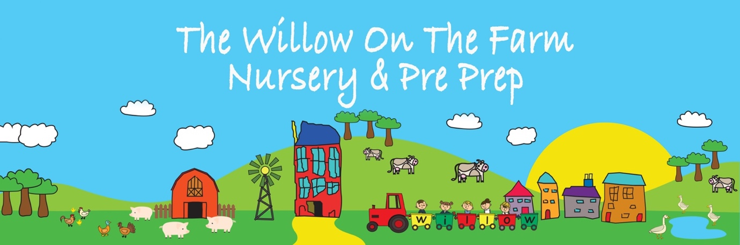

Anti Bullying Strategy

Approved by: | Alice Clark | Date: 8 January 2026
Last reviewed on: | Date of issue
Next review due by: | September 2026

1. Purpose and Relationship to the Behaviour Policy
This Anti-Bullying Strategy sits alongside and complements the school’s Behaviour Policy. It reflects the same relational, child-centred and developmentally informed approach, rooted in unconditional positive regard.
While bullying is not considered developmentally typical for most children aged 4–7, we recognise that repeated unkind or harmful behaviour can occur and must be addressed clearly, consistently and compassionately.
Our strategy prioritises:
- safety and wellbeing for all children
- early identification and prevention
- teaching empathy, kindness and repair
- supporting both the child who has been harmed and the child whose behaviour has caused harm

2. Ethos, Vision and Values
This strategy reflects our vision to allow children to be imaginative and creative through curiosity, awe and wonder, within a community that feels safe, respectful and caring.
Our response to bullying is guided by our core values:
- Confidence – children feel safe to speak up and trust adults to help
- Independence – children are supported to make positive choices and take responsibility
- Resilience – children are helped to recover from hurt and rebuild relationships
- A Caring Nature – empathy and compassion are explicitly taught and modelled
- Courage – children are encouraged to seek help and stand up for themselves and others
- Grace and Courtesy – respectful language, gentle behaviour and thoughtful actions are expected

3. What We Mean by Bullying (Age-Appropriate Definition)
Bullying is behaviour that:
- is repeated over time
- is intentionally hurtful, physically or emotionally
- involves a power imbalance, making it difficult for the child being targeted to stop it themselves
Bullying may be:
- physical (hitting, pushing, taking belongings)
- verbal (name-calling, repeated unkind words)
- relational (deliberate exclusion, repeated targeting)
- prejudice-based (related to race, disability, family, appearance, belief or difference)
We recognise that:
- one-off incidents, arguments or friendship fallouts are not bullying, but may still require support
- children of this age are still learning empathy and self-regulation
- behaviour must always be understood within a developmental context
If a child perceives themselves to be bullied, their concern will always be taken seriously.

4. Bullying, Safeguarding and the Law
Bullying may constitute child-on-child abuse and, in some cases, a safeguarding concern.
This strategy has regard to:
- Education and Inspections Act 2006
- Equality Act 2010
- Children Act 1989 and 2004
- Independent School Standards Regulations
- DfE guidance: Preventing and Tackling Bullying and Behaviour in Schools
Where bullying raises concerns about significant harm, the school’s Safeguarding and Child Protection Policy will be followed.

5. Preventing Bullying
5.1 Creating a Relational Culture
We aim to prevent bullying by:
- fostering strong, secure relationships between adults and children
- maintaining calm, predictable routines
- modelling respectful, inclusive behaviour at all times
- noticing and responding early to signs of distress or exclusion
5.2 Teaching Skills Explicitly
Through daily practice and the curriculum, children are supported to:
- recognise and name feelings
- understand how actions affect others
- practise kindness, empathy and inclusion
- learn language for setting boundaries and asking for help
Stories, role-play, reflection and real-life experiences are used to explore these themes in developmentally appropriate ways.
5.3 Partnership with Parents
We work closely with parents and carers to:
- share concerns early
- agree consistent language and strategies
- support children holistically

6. Responding to Bullying Concerns
6.1 Immediate Response
When bullying is suspected or reported:
- the child who has been harmed is listened to, believed and reassured
- immediate safety is prioritised
- the situation is addressed calmly and promptly
6.2 Investigation (Age-Appropriate)
Staff will:
- gather information sensitively from those involved
- consider frequency, intent, impact and power imbalance
- keep language neutral and non-blaming
Parents of all children involved will be informed.

7. Supporting Children Involved
7.1 Supporting the Child Who Has Been Harmed
Support may include:
- reassurance and emotional support
- increased adult presence or check-ins
- helping the child rebuild confidence and friendships
7.2 Supporting the Child Whose Behaviour Has Caused Harm
We recognise that children who bully often need support themselves. Responses focus on:
- helping the child understand the impact of their behaviour
- teaching alternative, prosocial behaviours
- repairing relationships through restorative approaches
- working with parents and, where appropriate, the SENDCo or external professionals
Sanctions are not punitive but may include proportionate, educational consequences aligned with the Behaviour Policy.

8. Recording and Monitoring
All bullying concerns and confirmed incidents are:
- recorded securely
- monitored for patterns or repetition
- reviewed by senior staff
Records are used to inform support and prevention, not to label children.

9. Roles and Responsibilities
Proprietor / Head of School
- ensures compliance with legislation and Independent School Standards
- oversees serious or persistent cases
- ensures staff training and review
All Staff
- model respectful behaviour
- remain vigilant to signs of bullying
- act promptly on concerns
- apply this strategy consistently
Parents and Carers
- share concerns promptly
- support agreed strategies
- reinforce messages of kindness and respect

10. Review and Evaluation
This Anti-Bullying Strategy is reviewed annually or sooner if required. Its effectiveness is evaluated through incident monitoring, staff reflection and parent feedback.

Our commitment:
We do not tolerate bullying, and we do not give up on children. We hold safety, dignity and belonging at the heart of our response, supporting every child to learn how to live well in community.

