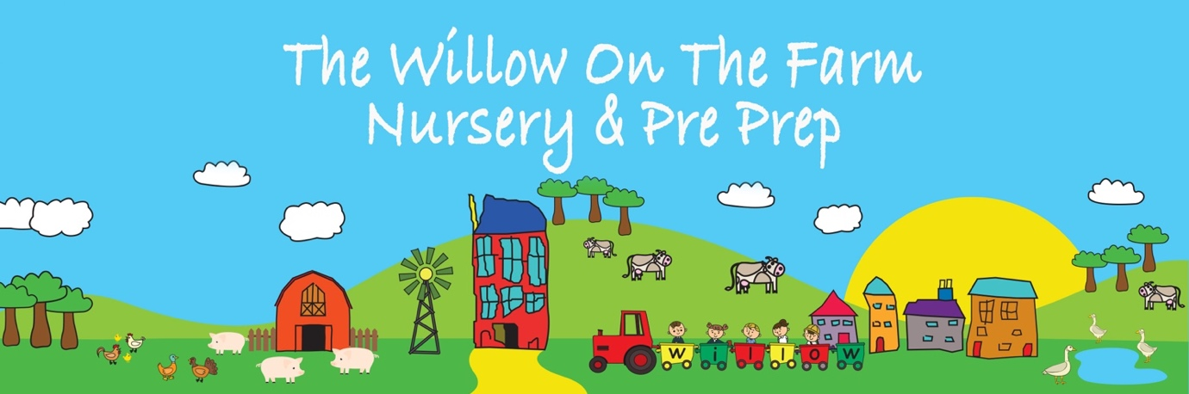

Behaviour Policy

Approved by: | Alice Clark | Date: 8 January 2026
Last reviewed on: | Date of issue
Next review due by: | September 2026

1. Policy Statement, Vision and Ethos
Our school’s behaviour policy is grounded in the vision and values of Willow on the Farm and reflects our belief that the early years of education are foundational to a child’s lifelong wellbeing, learning and sense of self.
Our Vision
We allow our children to be imaginative and creative through curiosity, awe and wonder. Our behaviour approach supports children to explore the world with confidence, openness and trust, knowing they are held in a safe, respectful and nurturing community.
Our Core Values in Action
Our expectations for behaviour are rooted in the values we seek to cultivate in every child:
- Confidence – children are supported to express their feelings, needs and ideas, and to trust that adults will listen and respond with care.
- Independence – children are encouraged to make choices, take responsibility for their actions and develop self-regulation skills appropriate to their age and stage.
- Resilience – children are supported to navigate challenge, conflict and strong emotions, learning that mistakes are part of growth.
- A Caring Nature – empathy, kindness and consideration for others, animals and the environment are explicitly taught and modelled.
- Courage – children are encouraged to try new things, speak up, and engage with difference in a supported and respectful way.
- Grace and Courtesy – respectful communication, gentle interactions and thoughtful behaviour are central to daily life in our school.
Our approach to behaviour is relational, developmentally informed and rooted in unconditional positive regard. This means that while behaviour may need to be guided, corrected or supported, a child’s worth, belonging and dignity are never in question.
We prioritise:
- strong, trusting relationships between children and adults
- emotional literacy and co-regulation
- clear, fair and age-appropriate expectations
- restorative approaches that repair relationships and build skills
This policy should be read alongside the Safeguarding and Child Protection Policy, SEND Policy, Anti-Bullying Policy and Complaints Policy.

2. Aims of the Policy
This policy aims to:
- support children to develop emotional regulation, empathy and self-awareness
- ensure the physical and emotional safety of all members of the school community
- promote positive behaviour through connection, modelling and guidance rather than punishment
- provide a consistent, transparent framework for staff, children and parents
- comply with all current UK legislation governing independent schools

3. Legal and Statutory Framework
This policy is written to meet the requirements of the Independent School Standards Regulations (ISSRs), in particular:
- Part 2: Spiritual, Moral, Social and Cultural development of pupils
- Part 3: Welfare, Health and Safety of pupils
- Part 6: Provision of information
It has regard to the following legislation and statutory or non-statutory guidance (as amended):
- Education Act 2002
- Education and Inspections Act 2006
- Children Act 1989 and 2004
- Equality Act 2010
- Behaviour in Schools: Advice for Headteachers and School Staff (DfE, 2024)
- Use of Reasonable Force in Schools (DfE)
- EYFS Statutory Framework (where applicable to Reception)
This policy applies to all pupils on roll, including when they are on school visits or engaged in off-site learning.
Corporal punishment is illegal and is never used or threatened.

4. Understanding Behaviour
We recognise that children aged 4–8 are still developing the neurological, emotional and social skills required for self-regulation. Behaviour may be influenced by:
- developmental stage
- unmet sensory or emotional needs
- tiredness, hunger or illness
- changes at home or school
- trauma, stress or anxiety
- additional needs or neurodiversity
Our response always seeks to understand why a behaviour is happening before deciding how to respond.

5. Promoting Positive Behaviour
5.1 Relationships First
Adults prioritise connection before correction. We:
- greet children warmly and consistently
- attune to children’s emotional states
- model calm, respectful communication
- narrate and celebrate positive behaviour
5.2 Clear Expectations
Expectations are kept simple, positive and age-appropriate, for example:
- we are kind and gentle
- we look after each other and our environment
- we listen to our bodies and feelings
These expectations are taught, revisited and modelled daily.
5.3 Emotional Literacy and Regulation
Children are supported to:
- recognise and name feelings
- understand that all feelings are valid
- learn safe ways to express big emotions
- develop strategies to return to a calm, regulated state
Adults co-regulate with children, gradually supporting them towards independence.

6. Responding to Behaviour That Challenges
6.1 Guiding Principles
All responses to behaviour are:
- calm and respectful
- proportionate and age-appropriate
- focused on learning and repair
- private wherever possible
Children are never shamed, humiliated, labelled or isolated.
6.2 Stepped Relational Response
Step 1: Support and Reminder
The adult notices and names what is happening, reminding the child of expectations and offering support.
Step 2: Co-regulation and Adjustment
The adult supports the child to regulate (e.g. movement, quiet space, sensory support, time with a trusted adult).
Step 3: Reflection and Repair
Once calm, the child is supported to reflect in an age-appropriate way:
- What happened?
- How did it feel?
- How can we make things right?
Step 4: Increased Support
If behaviours persist, staff will work with parents and the SENDCo (where relevant) to identify triggers and put supportive strategies in place.

7. Serious or Unsafe Behaviour
Physical Contact, Positive Handling and Physical Intervention
Given the age, developmental stage and needs of the children in our care, appropriate physical contact is sometimes necessary and forms a natural part of providing safe, nurturing and effective support. This may include, for example:
- offering comfort or reassurance to a distressed child
- guiding a child away from danger or intervening to prevent harm
- supporting children with personal care needs, such as helping with coats or footwear
- providing gentle guidance when demonstrating activities or supporting learning
All physical contact must always be appropriate, proportionate, necessary and in the best interests of the child, and must respect the child’s dignity, emotional wellbeing and right to feel safe. Staff are expected to use professional judgement and remain mindful of safeguarding responsibilities at all times.
Physical intervention, including the use of reasonable force, is used only as a last resort, and only to prevent injury or serious harm to the child or others, in accordance with DfE guidance Use of Reasonable Force in Schools. It is never used as a punishment or to secure compliance.
Wherever possible, staff should seek to ensure that physical contact takes place:
- in view of other adults, and/or
- with another member of staff present
Any significant, sustained or reactive physical contact (for example, physical intervention in response to conflict, or prolonged physical comfort) must be reported to a senior member of staff and recorded in line with the school’s safeguarding and record-keeping procedures. Parents will be informed where appropriate.
All concerns relating to physical contact, including situations that could be misinterpreted or give rise to unease, must be shared promptly in accordance with the school’s Safeguarding Policy and low-level concerns procedures. This supports a culture of transparency, reflection and continuous safeguarding vigilance.
Staff receive guidance and training to ensure that physical contact and any physical intervention are carried out safely, confidently, consistently and in line with safeguarding expectations.

8. Suspension and Exclusion
In line with the Independent School Standards and DfE guidance, suspension or permanent exclusion may be considered only where a pupil’s behaviour:
- represents a serious breach of this policy, and
- has a significant and ongoing impact on the safety, welfare or learning of the pupil or others, and
- where all reasonable, proportionate and supportive strategies have been exhausted.
Suspension or permanent exclusion is extremely rare and always used as a last resort, particularly given the age of the children in our care.
Only the Head of School / Proprietor may authorise suspension or permanent exclusion.
Parents will be:
- informed immediately of the decision and the reasons for it
- provided with written confirmation
- informed of their right to make representations under the school’s Complaints Policy
Where a pupil is suspended, meaningful and age-appropriate work will be provided where practicable.
The school will always consider its duties under the Equality Act 2010 and its safeguarding responsibilities when making decisions related to suspension or exclusion.
9. Children with SEND or Additional Needs
We recognise our duties under the Equality Act 2010. Behaviour policies are applied with flexibility and equity.
Where a child has SEND or emerging needs:
- behaviour is understood in context
- reasonable adjustments are made
- individual support plans may be created
- external professionals may be consulted with parental consent

10. Bullying
We do not expect bullying behaviours to be developmentally typical in children of this age. Repeated unkind behaviour is addressed as a safeguarding and relational concern and managed in line with the Anti-Bullying Policy.

11. Roles and Responsibilities
Proprietor / Head of School
The Proprietor / Head of School has overall responsibility for:
- ensuring this policy complies with current legislation and the Independent School Standards
- ensuring the policy is implemented consistently and fairly
- overseeing serious behaviour incidents, suspensions and exclusions
- ensuring appropriate staff training and support
- ensuring records are maintained securely and appropriately
All Staff
All staff are responsible for:
- modelling calm, respectful and emotionally attuned behaviour
- building secure, trusting relationships with children
- applying this policy consistently and proportionately
- supporting children to regulate emotions and repair relationships
- recording and reporting behaviour and safeguarding concerns appropriately
Parents and Carers
Parents and carers are expected to:
- work in partnership with the school
- communicate openly and respectfully with staff
- support agreed strategies and interventions
- engage constructively where concerns about behaviour arise

12. Record Keeping and Confidentiality
Behaviour incidents and any use of physical intervention are recorded securely in line with GDPR and safeguarding requirements. Records are used to inform support, not to label children.

13. Monitoring and Review
This policy is reviewed annually or sooner if required in response to legislative changes, inspection feedback or significant incidents.

This policy reflects our commitment to holding children in relationship, not control; in guidance, not punishment; and in belonging, always.

