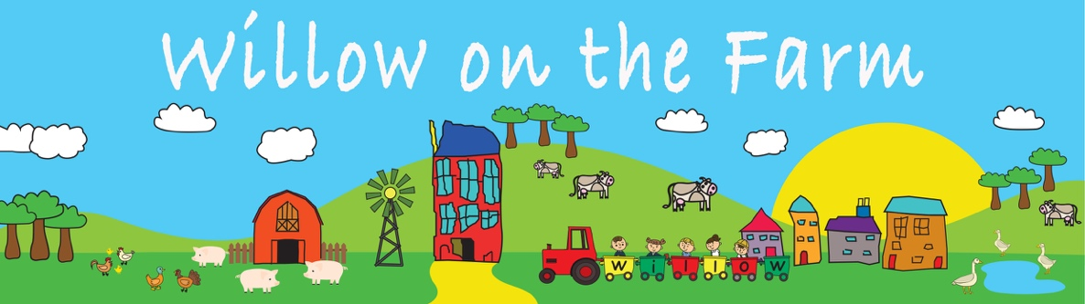

REGISTRATION FORM

Child’s Details

Full Name:
Preferred Name:
Name to learn to write:
Date of Birth:
Male/Female:

Term of Entry: | Autumn 20 |  | Spring 20 (Nursery only)
Age at Entry: (min 2yrs 6mths for  Nursery) | years |  | months
Intended duration of stay at Willow  on the Farm: | Nursery only (2yrs) | Nursery & Pre-Prep (5yrs) |  | Pre-Prep only (3yrs)

Parent/Carer Details
*Primary Contact will receive day-to-day communication and be added to our email & WhatsApp groups. Please let us know if Parent/Carer 2 should also be added.

 | Parent/Carer 1 (Primary)* | Parent/Carer 2
Title
Full Name
Home Address
Mobile
Home Telephone
Email Address
Occupation
Nationality
Religion
Parental responsibility
(Yes or No)

Name of current/previous school/nursery
(if applicable):

How did you hear about WOTF?
Does your child have any medical  requirements or allergies? | NO / Yes – Please give details:
Does your child have any disabilities or  special educational needs? | NO / YES – Please give details:
Would you like to join our mailing list? YES/NO

Registration Fee & Deposit
Registration Fee - £75 (due with this form and payable by BACS).
Deposits:
- Nursery only £800 (requested 18months before nursery start date to secure space for two years at Nursery and refunded from the final term of Swallows Class).
- Nursery & Pre-Prep £1800 (requested 18months before nursery start date to secure space to end of Year 2 and refunded from the final term of Year 2)
- Pre-Prep only £1000 (requested 18months before Reception start date to secure space to end of Year 2 and refunded from the final term of Year 2)

Bank: Lloyds Bank | Account Name: The Willow on the Farm Nursery Ltd
Account Number: 33745660 | Reference: Child’s Name
Sort Code: 30-98-98

Please see our Fee Documents for current session costs and details of Early Education Funding (Nursery only)

Nursery Sessions & Attendance

Goslings Class - a minimum of 4 sessions per week increasing to 5 sessions by the Summer Term. We try to ensure that all children are allocated their preferred sessions – However, this is not always possible in the Goslings Class as we can only have 18 children in each session as per the guidelines in the Early Years Foundation Stage Framework. Priority is given to our September intake with sufficient sessions reserved for our January intake.
Allocations are made in the order the requests are received.

Swallows Class - a minimum of 6 sessions per week to enable them to gain the most from the unique learning experience on offer at Willow on the Farm. Children in Swallows Class will be allocated their preferred sessions.

One-nursery setting – We know from experience, that a child’s learning journey can be set back and become confused, when learning from two different styles of teaching, making relationships with multiple staff and having different rules, routines and boundaries. Our Curriculum is a carefully planned two-year learning journey, and adding in another setting can be detrimental to their developmental progress.

Additional Information

Workplace Nursery Scheme – You may be eligible for tax savings on nursery fees via a workplace scheme. We currently work with the following schemes:
- Enjoy Benefits - https://www.workplace-nursery.net/workplace-nursery-benefits-for-parents/
- Kinsail - https://www.kinsail.co/

My Child at Home - intelligently selected activities for babies, toddlers, pre-schoolers and reception-age children to do at home. The system lets you observe any activity they’re doing now, review activities they’ve done, and evaluate their progress. It works on any mobile or tablet with Internet access.
Once your child starts at Willow on the Farm Nursery you can share access to the observations you have made with your child’s Key Person. Please visit https://mychildathome.com/demo to find out more.

